PUBLIC INTEREST DISCLOSURE PROCEDURE

Table of Contents

1 Introduction 2

2 Support for Those Who Make Public Interest Disclosures 2

3 Objectives of the Act 3

4 Awareness Raising 3

5 Designation of Public Interest Disclosure Worker 3

6 Receiving Public Interest Disclosures 4

7 Assessing a Public Interest Disclosure 5

8 Form of Public Interest Disclosure 6

9 Investigating a Public Interest Disclosure 6

10 Maintaining Confidentiality in an Investigation 7

11 Recording the Outcome of an Investigation 8

12 Taking Action Following an Investigation 9

13 Recording Action Taken 9

14 Reporting to a Discloser on the Progress and Outcome of an Investigation 9

15 Public Interest Disclosures are One Reporting Pathway 10

16 Victimisation and Reprisals 10

17 Confidentiality 10

18 Public Interest Disclosure Register 11

19 Reporting Requirements 11

20 Making Information Available 12

21 Recording Public Interest Disclosures 12

22 Public Interest Disclosure Resources 12

23 References 13

24 Monitoring, Evaluation and Review 13

25 Administration 13

Attachment 1 – WA Public Sector Commission PID Decision Tree 14

Attachment 2 – Duty Statement – PID Worker 15

# Introduction

The *Public Interest Disclosure Act 2003 (WA)* (the **Act**) enables people to make disclosures about wrongdoing within the state public sector, local government and Government Trading Enterprises (**GTEs**) without fear of reprisal. The Act aims to ensure openness and accountability in government by encouraging people to make disclosures and protecting them when they do.

This Procedure outlines the way the Mid West Ports Authority (**MWPA**) will comply with its obligations under the Act. The Procedure outlines the following.

* Disclosures of public interest information will be made to the Public Interest Disclosure Worker (**PID Worker**).
* The PID Worker shall investigate the information disclosed or cause that information to be investigated.
* The PID Worker may take action following the completion of the investigation.
* The PID Worker shall report to the discloser as to the progress and outcome of that investigation and the action taken as a consequence.
* The confidentiality of the discloser, and any person who may be the subject of a public interest disclosure, shall be maintained.
* Records relating to public interest disclosures will be maintained and reporting obligations complied with.

# Support for Those Who Make Public Interest Disclosures

MWPA has a zero-tolerance approach to corrupt or other improper conduct, by its Directors and Workers in the discharge of their work-related duties.

MWPA is committed to the aims and objectives of the Act. It recognises the value and importance of facilitating disclosure of corrupt or other improper conduct to enhance administrative and management practices.

Accordingly, MWPA will take all reasonable steps to provide protection to Directors and Workers who make such disclosures from any detrimental action in reprisal for the making of a public interest disclosure.

MWPA also has a zero-tolerance approach in relation to any of its Directors and Workers engaging in acts of victimisation or reprisal against those who make public interest disclosures.

# Objectives of the Act

The objectives of the Act are to:

* facilitate the disclosure of public interest information;
* provide protection for those who make disclosures; and
* provide protection for those who are the subject of a disclosure.

This is achieved by:

* protecting the person making the disclosure from legal or other action;
* providing for the confidentiality of the identity of the person making the disclosure and a person who is the subject of a disclosure; and
* providing remedies for acts of reprisal and victimisation that occur substantially because the person has made a disclosure.

# Awareness Raising

This Procedure outlines how MWPA meets its obligations under the Act. These obligations detail the roles and responsibilities of MWPA, and the person designated as the proper authority in accordance with s. 23(1)(a) and   
s. 5(3)(h) of the Act, referred to in this document as the PID Worker, the discloser, and the subject of the disclosure.

This Procedure is to be read in conjunction with the PID Act, *Public Interest Disclosure Regulations 2003* and the Public Sector Commission’s Guide for Disclosers ‘*Don’t be afraid to speak up*’.

MWPA will ensure that its Directors, Workers and members of the community are informed about public interest disclosure procedures through:

* MWPA Induction process;
* MWPA Code of Ethics and Conduct;
* Training programs; and
* Information published on Intranet and Website.

# Designation of Public Interest Disclosure Worker

The PID Worker is designated to the position of Chief Environmental, Social and Governance Worker (**CESGO**); in the absence of the CESGO, the PID Worker will be assigned to the IMS Coordinator. The PID Worker is responsible for receiving disclosures of public interest information relating to matters falling within the sphere of responsibility of the MWPA.

After assuming or beginning to act in the position of CESGO, the person holding or acting in that position must forward a completed PID Worker’s Declaration to the Office of the Public Sector Standards Commissioner. A copy of the completed PID Worker’s Declaration shall be recorded and preserved as evidence of this transaction.

The roles and responsibilities of the PID Worker are detailed within the MWPA **Public Interest Disclosure Duty Statement** (Attachment 2)**.**

# Receiving Public Interest Disclosures

Before a discloser makes a public interest disclosure to a PID Worker, the PID Worker shall advise the discloser of the following matters.

1. If they choose to make a public interest disclosure, they will not (unless the claim is found to be vexatious in nature) as a result:
   * incur any civil or criminal liability;
   * be liable to any disciplinary action under law;
   * be liable to be dismissed or have his or her services dispensed with or otherwise terminated; and
   * be liable for any breach of a duty of secrecy or confidentiality or any other applicable restriction on disclosure.
2. If they choose to make a public interest disclosure, they may have the right to take civil proceedings if they are subject to detrimental action as a result of making the disclosure.
3. If they choose to make a public interest disclosure, then their identity will not be disclosed except in accordance with the Act (disclosure of their identity may be required in the course of the investigation or in acting in some circumstances).
4. If they choose to make a public interest disclosure they will have the right to be informed of the progress, outcome of the investigation and action taken as a result.
5. If they choose to make a public interest disclosure:
   * they are only protected if they believe on reasonable grounds that the information to be disclosed is or may be true;
   * they will commit an offence, and lose the protection of the Act, if they know the information to be false or misleading in a material particular or are reckless about whether the information is false or misleading in a material particular;
   * they will forfeit the protection given by the Act if they disclose the information otherwise than under the Act (that is, if they provide the information to the media or a person who is not a proper authority);
   * they will forfeit the protection given by the Act if they fail, without reasonable excuse, to assist a person investigating the matter to which the information relates, by supplying any information requested;
   * they may commit an offence if they disclose information that might identify or tend to identify anyone as a person in respect of whom a disclosure of public interest information has been made; and
   * the disclosure will only be protected if the PID Worker is the proper authority for receiving that kind of information, as indicated in the following table.

| When the disclosure relates to… | The proper authority is… |
| --- | --- |
| The sphere of responsibility of a public authority (for example, matters about the public authority or its Workers, or which the public authority has the function of investigating) | The Public Interest Disclosure Worker (PID Worker) of the Public Authority |
| Offences under State law | A police Worker or the Corruption and Crime Commission |
| Substantial unauthorised or irregular use of, or substantial mismanagement of, public resources | The PID Worker of the public authority concerned, or the Auditor General |
| Matters of administration affecting someone in their personal capacity falling within the jurisdiction of the Ombudsman | The PID Worker of the public authority concerned or the Ombudsman |
| A police Worker | The Commissioner of Police or the Corruption and Crime Commission |
| A Member of the Legislative Council | The President of the Legislative Council |
| A Member of the Legislative Assembly | The Speaker of the Legislative Assembly |
| A judicial Worker | The Chief Justice |
| A public Worker who is not a member of Parliament, a Minister, a Judicial Worker or a Commissioned or other Worker specified in **Schedule 1** of the *Parliamentary Commissioner Act 1971* | The PID Worker of the public authority concerned, the Ombudsman or the Commissioner for Public Sector Standards |
| A person or a matter of a prescribed class | A person declared by the regulations to be a proper authority |

# Assessing a Public Interest Disclosure

On receiving the information, the PID Worker must confirm that the discloser wishes to make a public interest disclosure under the Act. If they do, the PID Worker must make an initial assessment of whether:

* the information disclosed relates to a public authority, worker or contractor;
* the information disclosed relates to the performance of a public function;
* the information disclosed tends to show improper conduct;
* the improper conduct is of the kind for which the PID Worker is the proper authority (see the table above);
* the discloser believes on reasonable grounds that the information is or may be true; and
* the information is not protected by legal professional privilege.

If the above questions are all answered ‘**yes**’, then the disclosure of information is a public interest disclosure to which the Act will apply. The PID Worker must notify the CEO immediately and advise of the appropriate course of action.

# Form of Public Interest Disclosure

If a disclosure is a public interest disclosure, the discloser and the PID Worker should complete the Public Interest Disclosure Lodgement Form (on the **OPSSC Website[1]**). The PID Worker should also complete **Part 2** of the **Assessment Form for Public Interest Disclosures**.

On completion of this form, the PID Worker should create a separate file for the Public Interest Disclosure, with the following text clearly marked on the front of the File.

*“CONFIDENTIAL*

*The material in this file relates to a public interest disclosure made under the Public Interest Disclosure Act 2003.*

*Disclosure of information that might identify or tend to identify either the discloser or a person in respect of whom the disclosure has been made is an offence, unless the disclosure occurs in accordance with the Act.*

*Penalty: $24,000 or imprisonment for two years.”*

The making of the public interest disclosure should also be recorded in the **Public Interest Disclosure Register**, for reporting to the Commissioner for Public Sector Standards.

# Investigating a Public Interest Disclosure

After receiving a disclosure, the PID Worker must consider whether:

* the disclosure relates to the MWPA, its Workers or contractors; and
* the disclosure relates to a matter or person that MWPA has a function or power to investigate.

If the answer to both questions is ‘**no**’, the PID Worker is not required by the Act to investigate the matter.

Where the PID Worker considers that he or she lacks sufficient power to effectively investigate the matter, but the information received causes him or her to form the opinion that a public authority, Worker or contractor may have engaged in improper conduct, the PID Worker should refer the matter to another appropriate investigative body.

The PID Worker must also consider whether:

* the matter is trivial;
* the disclosure is vexatious or frivolous;
* there is no reasonable prospect of obtaining sufficient evidence due to the time that has elapsed since the occurrence of the matter; and
* the matter is being, or has been adequately or properly investigated by another proper authority, to which an appropriate disclosure of public interest information has been made under the Act.

If the answer to any of these questions is ‘**yes**’, the PID Worker is not required by the Act to investigate the matter.

Where the PID Worker determines that the disclosure is a public interest disclosure that should be investigated, the Worker must investigate the disclosed matter himself / herself or engage another person to carry out the investigation.

In investigating, typical matters could include:

* drawing up terms of reference, which should clarify the key issues identified by the disclosure;
* specifying a date by which the investigation should be completed;
* ensuring the objectives of the investigation include collecting and collating information relating to the disclosure, considering the information collected and drawing conclusions objectively and impartially;
* maintaining procedural fairness for the person who is the subject of the disclosure;
* giving information to the person who is the subject of a disclosure about their rights and obligations under the Act, the Code of Conduct and Integrity, any agency code of conduct, and the law;
* the investigator making contemporaneous notes of discussions and interviews and, where practicable and appropriate, recording discussions and interviews on audio or videotape; and
* ensuring strict security with all investigations, so as to maintain the confidentiality requirements of the Act.

If a disclosure is withdrawn, a proper authority may still continue to investigate the issues raised.

# Maintaining Confidentiality in an Investigation

The Act imposes strict confidentiality requirements in relation to the identity of the discloser and persons in respect of whom a public interest disclosure has been made. The disclosure of information which might identify or tend to identify these persons, except in accordance with the Act, is a serious offence, with a maximum penalty of $24,000 or two years imprisonment.

The confidentiality provisions of the Act do not apply to all information disclosed in a public interest disclosure, but only to information that might identify or tend to identify the discloser and persons in respect of whom a public interest disclosure has been made.

One of the circumstances in which identifying information may be disclosed is with the consent of the person concerned. It is important that this consent be recorded. The Consent to Disclosure of Identifying Information form should be used for this purpose (see OPSSC website).

Identifying information relating to a discloser may be disclosed without the discloser’s consent where:

* it is necessary to do so, having regard to the rules of natural justice; or
* it is necessary to do so to enable the matter to be investigated effectively.

However, before information is disclosed for these reasons the person making the disclosure must take all reasonable steps to inform the person whose identity is to be disclosed:

* that the disclosure is being made; and
* the reasons for the disclosure being made.

This information should be given, where practicable, in the form for Notification of Disclosure of Identifying Information (see OPSSC website).

Where identifying information in relation to a discloser is conveyed to another person for these reasons, the other person should be warned that disclosure of the information to a third person may involve a serious offence.

Identifying information relating to a person in respect of whom a public interest disclosure has been made can be disclosed at the investigation stage where the disclosure:

* is necessary to enable the matter to be investigated effectively; or
* there are reasonable grounds to believe that the disclosure of identifying information is necessary to prevent or minimise the risk of injury to any person or damage to any property.

In addition, disclosures made in accordance with ***Sections 152*** or ***153*** of the ***Corruption and Crime Commission Act*** are exempt from these confidentiality requirements.

Particularly, where a discloser works for the MWPA, protecting the identity of the discloser is an important part of protecting the discloser from reprisals and victimisation. Careful consideration must be given as to whether the disclosure of information that might identify or tend to identify a discloser is necessary for the effective investigation of the matter or having regard to the rules of natural justice.

Where a PID Worker appoints a third person to investigate in relation to the public interest disclosure, he / she must consider whether it is necessary to inform the investigator of the identity of the discloser. In some cases, it may not be necessary to provide the investigator with the identity of the discloser. Where it is necessary, to enable an effective investigation, or having regard to the rules of natural justice, to provide identifying information to the investigating Worker, then the discloser should be notified in the manner described above.

# Recording the Outcome of an Investigation

The outcome of an investigation should be clearly and comprehensively recorded in MWPA’s Recordkeeping system (EDRMS). In addition to any investigation report, the person conducting the investigation should complete **Part 4** of the **Assessment Form for Public Interest Disclosure** (see OPSSC website).

The result of the investigation should also be recorded in the Public Interest Disclosure Register. All reporting requirements to the Commissioner for Public Sector Standards required under the Act will be based on extracts from this Register.

# Taking Action Following an Investigation

The PID Worker must act where they form the opinion that a person may be, or has been, or may in the future be, involved in improper conduct. Action that may be taken includes:

* preventing the matter to which the disclosure relates from continuing or occurring;
* referring the matter to the Police or other appropriate body, or
* taking disciplinary action against a person responsible for the matter.

Before taking any action, the person against whom the action is to be taken is to be given the opportunity to make written or oral submissions.

In taking that action the PID Worker remains limited by the powers and functions that are conferred by the legislation under which the PID Worker operates. The Act does not give the PID Worker additional powers to act.

As well as being limited to matters within the functions and powers of the PID Worker, the action to be taken is guided by what is necessary and reasonable.

# Recording Action Taken

In addition to keeping other records, the PID Worker shall complete **Part 5** of the **assessment form** for Public Interest Disclosures (see OPSSC website) and record a summary of the action taken in the Public Interest Disclosure Register. All reporting requirements to the Commissioner for Public Sector Standards required under the Act will be based on extracts from this Register.

# Reporting to a Discloser on the Progress and Outcome of an Investigation

Where the PID Worker decides not to investigate information disclosed under the Act, or discontinues an investigation, the PID Worker must give the person who made the disclosure reasons for doing so.

Within three months of the disclosure being made the PID Worker must notify the discloser of the action taken or proposed to be taken in relation to the disclosure.

A discloser may also request a progress report.

If an investigation is not complete, the PID Worker may provide to the discloser a progress report on the current status of the investigation.

If an investigation is complete, the PID Worker must provide a final report to the discloser, stating the outcome of the investigation and the reason for acting following the investigation.

In providing information and reports to disclosers, the PID Worker must not give information that, in the Worker’s opinion, would be likely to adversely affect:

* any person’s safety;
* the investigation of an offence or possible offence; or
* necessary confidentiality as to the existence or identity of another person who has made a disclosure of public interest information under the Act.

# Public Interest Disclosures are One Reporting Pathway

A MWPA Director or Worker may choose one of the below alternate avenues for reporting, for example, they think it would be hard to keep their information confidential among friends or colleagues, or they want an outcome that is not possible using the public interest disclosure process. Making a public interest disclosure usually limits people from providing the same information in other circumstances.

Some of the other avenues for reporting your information include the:

* Corruption and Crime Commission for serious misconduct;
* Public Sector Commission for minor misconduct;
* Western Australia Police for criminal matters;
* Ombudsman Western Australia for matters governing administration affecting individuals; or
* Equal Opportunity Commission Western Australia for matters regarding discrimination.

# Victimisation and Reprisals

The MWPA has zero-tolerance to any acts of victimisation or reprisal as a result of a person making, or proposing to make, a public interest disclosure.

Any victimisation or reprisals must be reported immediately to the Human Resources and Industrial Relations Manager and the PID Worker (if different), who must take immediate action to prevent the continuance of this unlawful conduct.

Where victimisation or reprisals are reported, a record of the report and the action taken must be placed on the file relating to the public interest disclosure.

Steps taken to prevent acts of victimisation or reprisal should be recorded in a manner that they will be accessible for reference, should legal action be taken against the MWPA.

# Confidentiality

The confidentiality requirements in relation to information which might identify or tend to identify a discloser or a person in respect of whom a public interest disclosure has been made must be complied with at all times. The disclosure of this identifying information, except in accordance with the Act, is an offence.

All files relating to a public interest disclosure, whether paper or electronic, must be secure and accessible only by authorised persons. Files should carry clear warnings that there are penalties for unauthorised divulgence of information concerning a disclosure.

It is strongly recommended that sensitive information is not emailed or faxed to machines with general or shared access.

# Public Interest Disclosure Register

The MWPA shall maintain a Public Interest Disclosure Register recording a unique reference number on the register including a summary of information as follows.

* The discloser
* Public authorities about which a disclosure is made
* People named in the disclosure
* The nature of the disclosure
* The investigation process and the action, if any, taken
* Communication with the discloser
* The discloser’s identity, if applicable
* The identity of persons named in the disclosure
* Any claims of unlawful disclosure of discloser’s identity or identity of persons named in the disclosure
* Any claims of victimisation
* Key dates

Additional information may also be recorded in MWPA Public Interest Disclosure Register at the discretion of the public authority.

All reporting requirements to the Public Sector Commissioner required under the Act will be based on extracts from the fields shown in the sample Register.

# Reporting Requirements

Under **Section 23 (f)** of the Act, the MWPA is required to report annually to the Commissioner for Public Sector Standards on:

* the number of public interest disclosures received over the report period;
* the results of any investigations conducted as a result of the disclosures; and
* the action, if any, taken as a result of each investigation.

To enable the Commissioner and the Minister to meet their obligations MWPA will provide a report each year on compliance with and administration of the Act as requested by the Commissioner.

An electronic format for the Chief Executive Officer Report and the information for the Commissioner’s Compliance Report will be provided each year by the Commissioner and both will be able to be submitted in a single electronic submission. The reports will cover the period 1 July in any year to 30 June in the subsequent year.

Where there has been no action on a disclosure in the reporting period the format of the report will provide for a simple nil return. Where action relating to one or more disclosures has occurred, all data required will be obtainable as a simple extract from the Public Interest Disclosure Register.

# Making Information Available

These internal procedures shall be made available for access by all Directors, Workers and Members of the public. Copies of these internal procedures are available from the Public Interest Disclosure Worker and are to be kept on the MWPA Intranet and website.

Where a person makes an allegation about improper conduct, but the person has not referred to the Act, the person should be advised that they might want to make a public interest disclosure under the Act. If they may wish to do so, they should be referred to the PID Worker for guidance on how to make a disclosure under the Act and on the implications of having done so.

# Recording Public Interest Disclosures

During the investigation the PID Worker may make comprehensive and contemporaneous records of any discussions and interviews. These records along with any other documentation or files relating to the disclosure, whether paper or electronic, will be stored securely within MWPA’s Recordkeeping system (EDRMS), and only accessed by authorised persons, currently, the CEO, CESGO, Chief Financial Worker (**CFO**) and Records Management Advisor (**RMA**).

# Public Interest Disclosure Resources

The Public Sector Commission and the Corruption and Crime Commission have many resources available to PID Workers on their websites.

<https://www.wa.gov.au/government/document-collections/public-interest-disclosure-resources>

and

<https://www.ccc.wa.gov.au/reporting-corruption>

Some key tools that could be utilised by MWPA to assist PID Workers in the investigation and reporting of PID and other disclosures are the ‘***Assessment and Case Management Form for a Public Interest Disclosure***’ and the ‘***What is minor misconduct?***’ fact sheet from the PSC and ‘***’Reporting serious misconduct***’ fact sheet from the CCC.

# References

|  |  |
| --- | --- |
| Act or Reg | Description |
| *Public Interest Disclosure Act 2003 (WA)* | *Section 23(1)(a)* |
| *Section 5(3)(h)* |
| *Public Interest Disclosure Regulations 2003* |  |
| *Parliamentary Commissioner Act 1971* | *Schedule 1 - A public Worker* |
| *Corruption and Crime Commission Act 2003 (WA)* | *Sections 152 or 153* |

*Location:* Western Australian **-** <https://www.legislation.wa.gov.au/> Australian - <https://www.legislation.gov.au/>

# Monitoring, Evaluation and Review

This document is required to be reviewed every **two years** from the last scheduled review date or on amendment of the *Public Interest Disclosure Act 2003 (WA)* and the *Corruption and Crime Commission Act 2003 (WA)*.

Minor updates made within this **two year** period, will not be taken as a full review.

The Document Custodian is responsible for conducting the review in accordance with **Controlled Documents Review and Approval Process**.

# Administration

Document Custodian: IMS Coordinator

Document Approver: Chief Environmental Social and Governance Officer

Approval Date: 27 August 2024

Document Review Period: 2 yrs

# Attachment 1 – WA Public Sector Commission PID Decision Tree

|  |  |
| --- | --- |
|  |  |

[2]

# Attachment 2 – Duty Statement – PID Worker

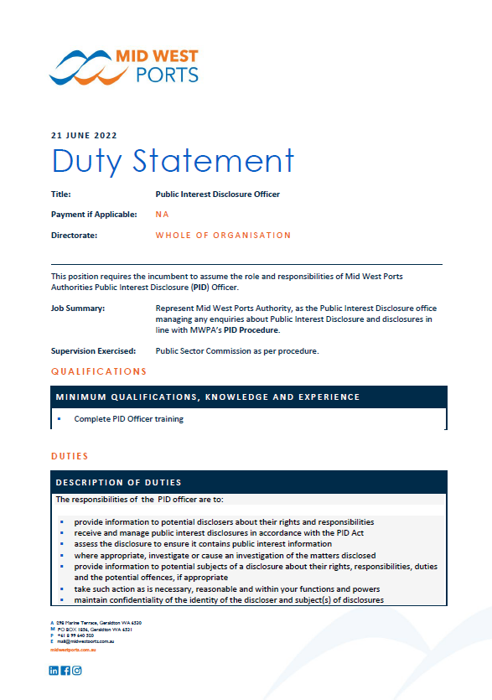

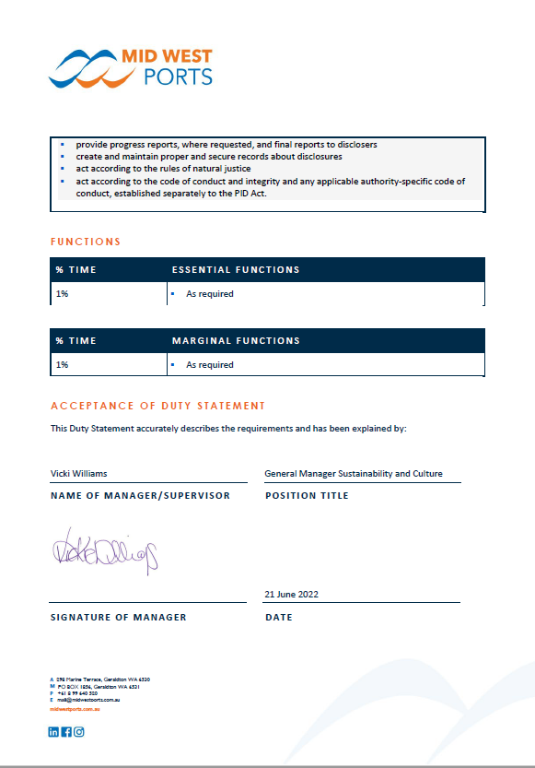

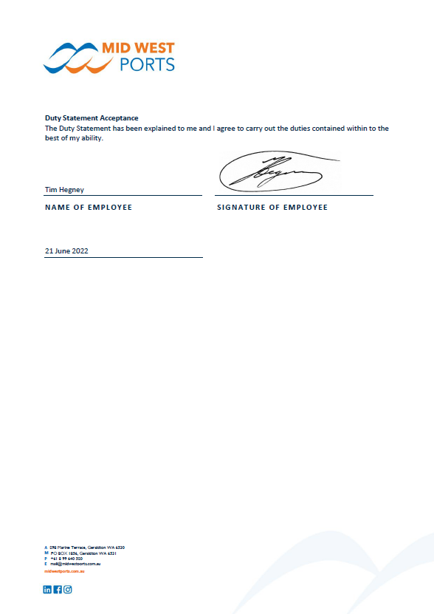

1. Public Interest Disclosure Lodgement Form

   <https://www.wa.gov.au/government/publications/public-interest-disclosure-lodgement-form>
2. <https://www.dbca.wa.gov.au/sites/default/files/2021-05/Public%20Sector%20Commission%20-%20When%20someone%20speaks%20up%20-%20Guide%20for%20Managers.pdf>